Design

COIN DETECTOR

1. User deposits coin into coin slot on outside of machine. Coin slot is dimensioned to the width and height for the thickest and largest diameter coin to be accepted.   
2. Coin rolls down a chute and past identification probe that determines the denomination by the coin’s material properties.  The probe consists of two solenoids with their axis perpendicular to the longitudinal wall of the chute.  Current is run through one solenoid which then generates a **B** field perpendicular to the coin axis of revoluion.  The magnetic field passes through the coin, is attenuated by the coin's material properties and geometry before being received by the solenoid at the opposite end.  The **B** field passing along the axis of the second coil generates a specific pattern of electric current, which can be matched with the correct coin.   
3. a) Coin also activates switch that b) pulls slide member toward wall of chute by means of electromagnet, thereby preventing another coin from entering.

4. The probe sends information to timing mechanism for turning on of electromagnetic device that opens flap armature.

5. Coin falls down chute and onto first sorting weigher. The number of denominations to be accepted determines the number of sorting weighers.

6. Sorting weigher pivots under the weight of coin and coin rolls toward chute.   
7. Electromagnet turns on and the coin’s specific flap armature opens momentarily allowing coin to fall through chute.

8. Coin rolls down chute to be sorted.

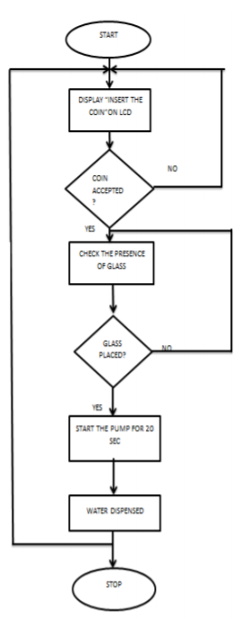

Metering System

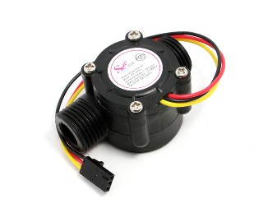

**Description**

Water flow sensor consists of a plastic valve body, a water rotor, and a hall-effect sensor. When water flows through the rotor, rotor rolls. Its speed changes with different rate of flow. The hall-effect sensor outputs the corresponding pulse signal. This one is suitable to detect flow in water dispenser or coffee machine.

**Features**

* Compact, Easy to Install
* High Sealing Performance
* High Quality Hall Effect Sensor
* RoHS Compliant

**Specifications**

* Mini. Wokring Voltage: DC 4.5V
* Max. Working Current: 15mA (DC 5V)
* Working Voltage: DC 5V~24V
* Flow Rate Range: 1~30L/min
* Load Capacity: ?10mA (DC 5V)
* Operating Humidity: 35%~90%RH
* Water Pressure: 1.75MPa
* Storage Temperature: -25~+ 80 0C

The pulse signal is a simple square wave so its quite easy to log and convert into liters per minute using the following formula.

Pulse frequency (Hz) / 7.5 = flow rate in L/min.

**Cup Seperator Mechanism:**

1)Servo Motor

The 10kg.cm Metal Gear Servo Motor - MG995 can rotate approximately 180 degrees (90 in each direction).

It can be used with hardware  or  library  to  control  these  servos,  so  it's  great.  The MG995 Metal Gear Servo also has a selection of arms and hardware to get nice set up.

**Features:**

* Operating voltage: 4.8 V a 7.2 V
* Temperature range: 0 ºC – 55 ºC
* Control System: Analog
* Operating Angle: 180degree
* Required Pulse: 900us-2100us
* Direction: CCW
* Weight: 55 g
* Dimension: 40.7 x 19.7 x 42.9 mm approx.
* Stall torque: 8.5 kgf·cm (4.8 V ), 10 kgf·cm (6 V)
* Stable and shock proof double ball bearing design.

2) Cup Seperator:

Cup separator is made with slot included in it so that the paper cup of diameter 75 mm may accommodate with its rounded edge. This mechanism need a stack of the paper glass above it in fixed position. So, that when the crank attached to the servo motor, rotates and gives linear motion to the cup separator shown in the figure.

The paper glass then falls due to gravity through the PVC pipe. This pipe has diameter greater than paper glass so that it should pass easily without any resistance. Guides in the shape of C section are attached to the main mechanism to impart the sustainability towards vertical and horizontal displacements.

Wedge angle is fixed after iterations to provide the easy and simple movement of paper glass inside the slot. This wedge also connects the guides of C sections attached to the mechanism to the base.

For the given sider-crank mechanism;

Total required displacement of the mechanism=18cm

So, length of crank=(Mechanism displacement/2)= 9cm

Connecting rod length can be taken above 10cm to the 22cm………(Since, the sum of any two sides of triangle must be greater than other side)

